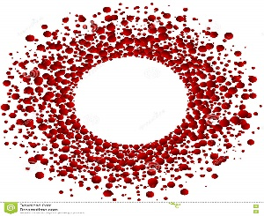

Mohammed S. Qayyum, MD, PhD
Ethan HM. Daniels, MD
Heart & Vascular Diseases
www.msqmdinc.com

NEW PATIENT REGISTRATION FORM

Legal Name: __________________________________________ DOB: ______________

Address: _______________________________________________ Zip ______________
Best Telephone #: ____________________ Home Cell Work (please circle)

Email Address: __________________________________________

Employer: _________________________________ Occupation:____________________

Referring Physician _______________________Primary Care Physician _____________

Emergency Contact: __________________________Relation: _____________________
Emergency Contact# : _____________________________________________________

Primary Language: ___________________________ Gender: _____________________
Ethnicity/Race: ______________________

Preferred Pharmacy: _______________________________________________________

Tobacco Use: Never Current Former Quit: _____________
Alcohol Use: Never Occasional Everyday Amount: __________

Medical History/Surgeries: __________________________________________________
________________________________________________________________________
________________________________________________________________________
Patient Signature:

Date:
**Please bring all your medication bottles to your appointment. Thank you.**

__________________________________________________________________
2505 Samaritan Drive Suite 205 Office 408.610.2001
San Jose, CA 95124 Fax 408.610.3880

