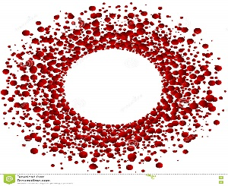

Mohammed S. Qayyum, MD, PhD
Ethan HM. Daniels, MD
Heart & Vascular Diseases
www.msqmdinc.com

MEDICAL RECORDS RELEASE FORM

I, ________________________________ hereby authorize the release of the requested

records listed below to the office of Mohammed S. Qayyum, MD INC. Thank you.

________________________________________________________________________

________________________________________________________________________

________________________________________________________________________

________________________________________________________________________

________________________________________________________________________

Patient Signature:

Print: ___________________________________________________ DOB: __________

Date:

__________________________________________________________________
2505 Samaritan Drive Suite 205 Office 408.610.2001
San Jose, CA 95124 Fax 408.610.3880

