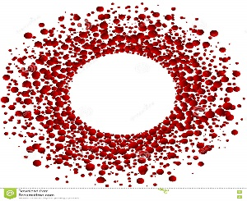

**Mohammed S. Qayyum, MD, PhD**

**Ethan HM. Daniels, MD**

Heart &Vascular Diseases

www.msqmdinc.com

HIPPAA Privacy Authorization Form

Authorization to Use or Disclosure of Protected Health Information

(Required by the Health Insurance and Accountability Act- 45 CFR Parts 160 & 164)

I, _________________________________________ give authorization for release of my protected health information (PHI) to Mohammed S. Qayyum MD INC

regarding my billing, condition, treatment and prognosis to the following individuals:

*Name _______________________________ Relationship_________________

*Name _______________________________ Relationship_________________

*Name _______________________________ Relationship_________________

*Name _______________________________ Relationship_________________

I understand that I have the right to revoke this authorization verbally and/or in writing at any time. I understand that a revocation is not effective to the extent that any person or entity has already acted in reliance on my authorization.

I also understand that information used or disclosed pursuant to this authorization

may be disclosed by the recipient and may no longer be protected by federal/state law.

Patient Signature_____________________________________Date___________

__________________________________________________________________

2505 Samaritan Drive Suite 205 Office 408.610.2001

San Jose, CA 95124 Fax 408.610.3880